DIGITAL ASSIGNMENT 2

ABHIRUPA MITRA
17BCE0437

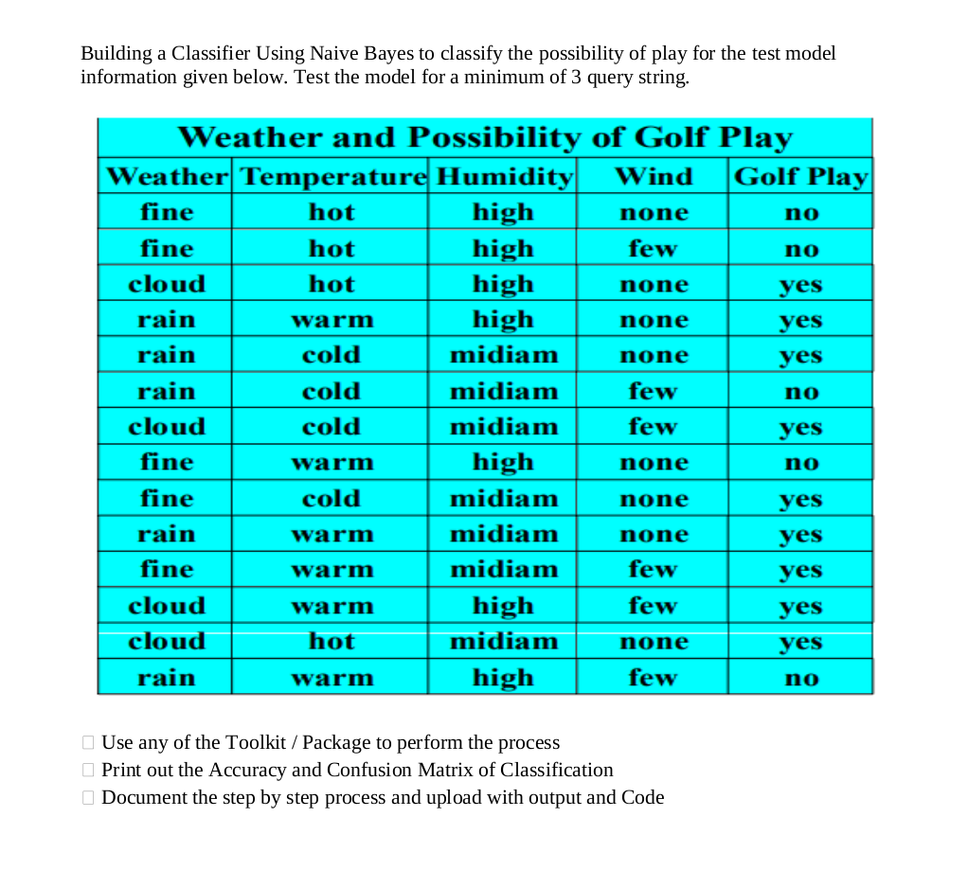

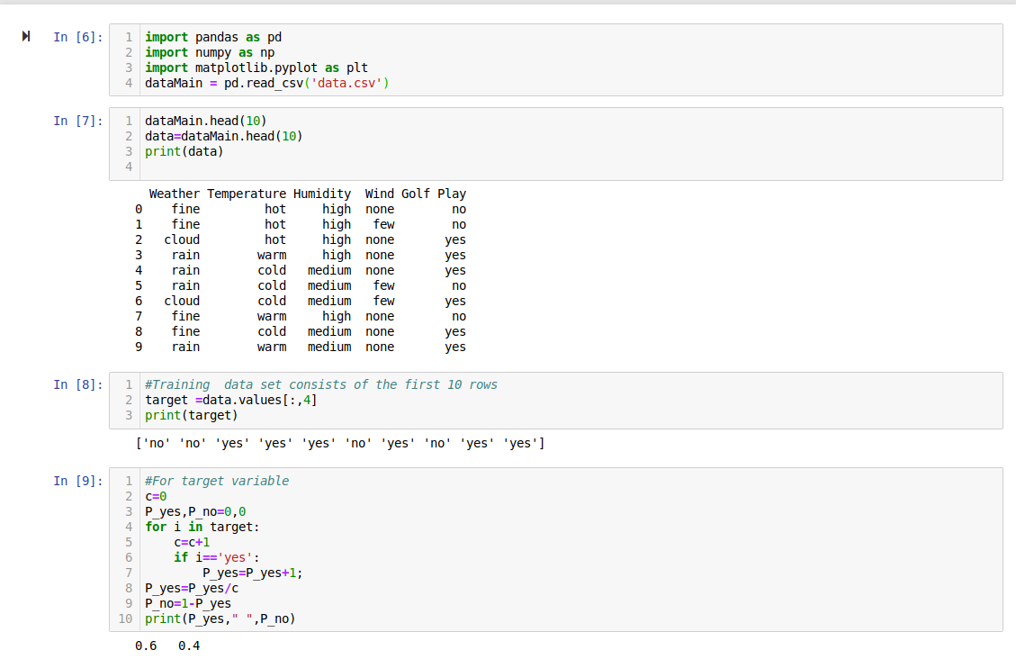
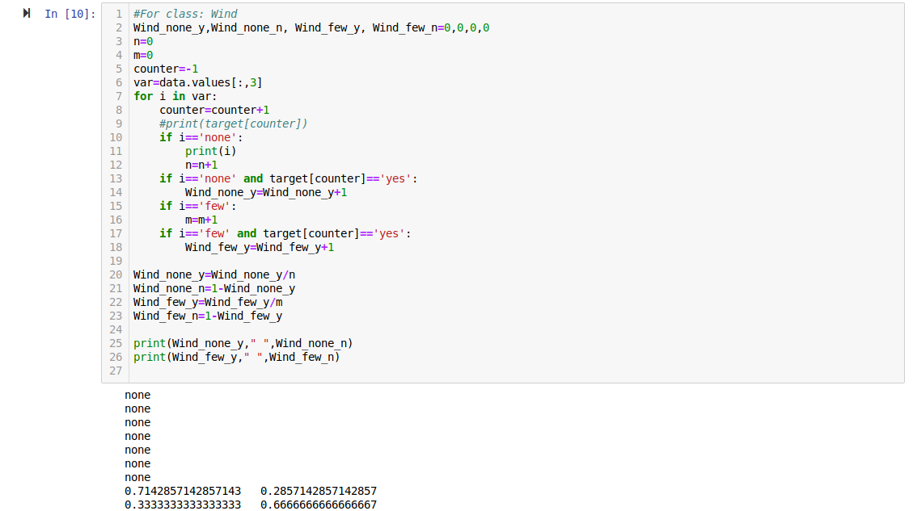

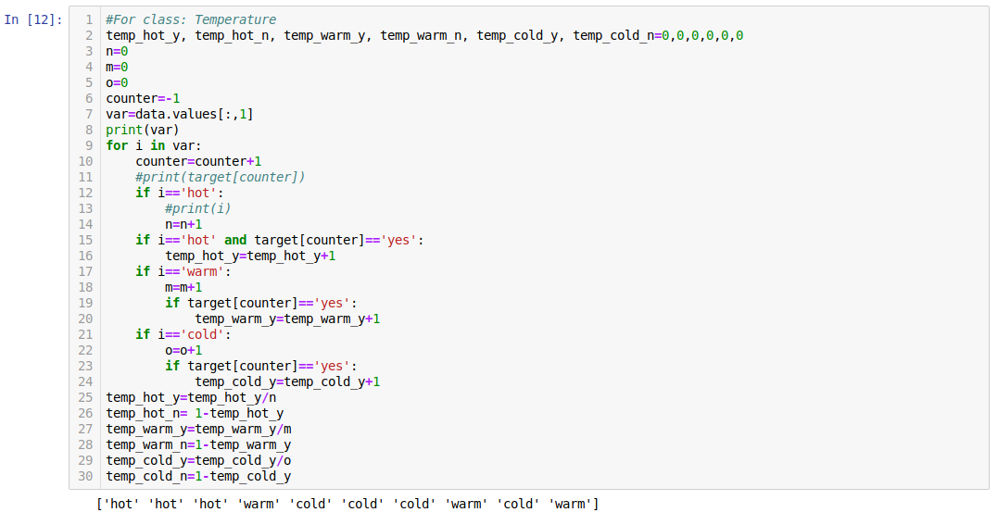
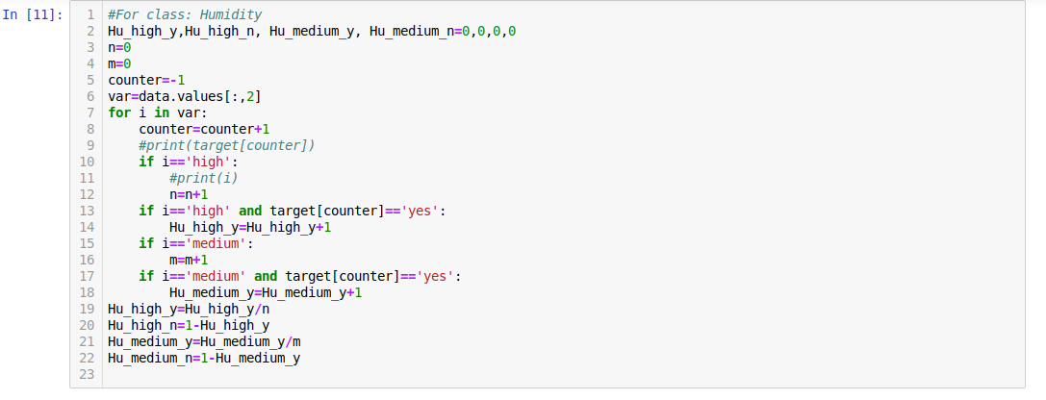

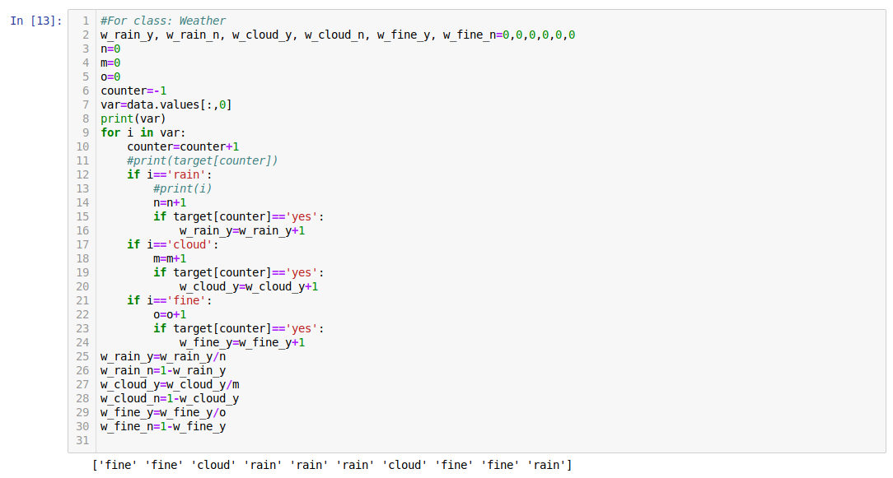
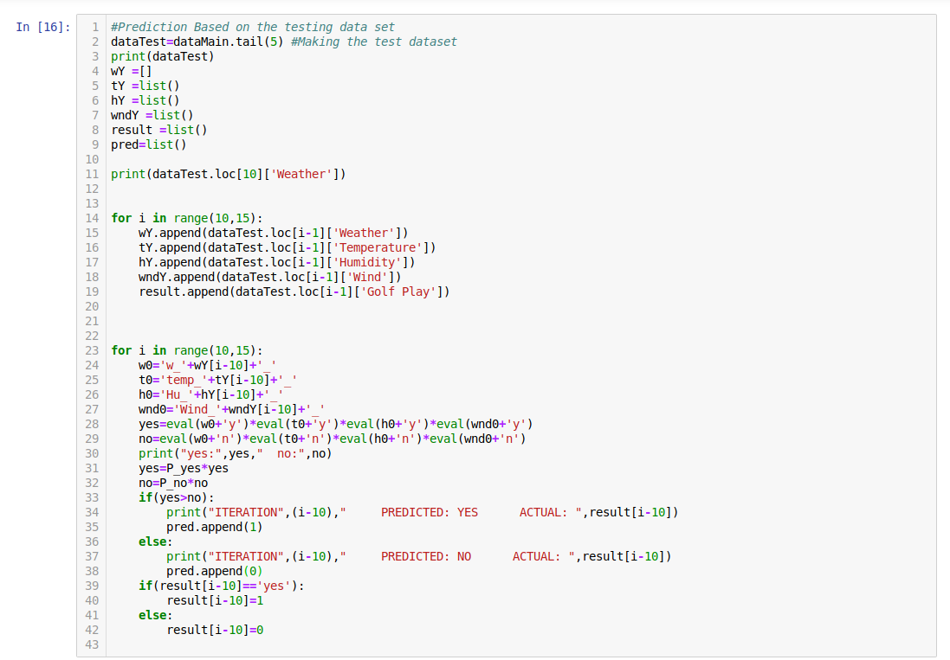
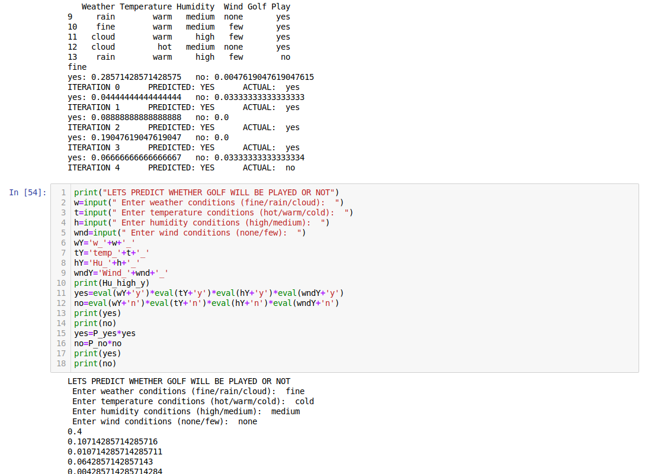

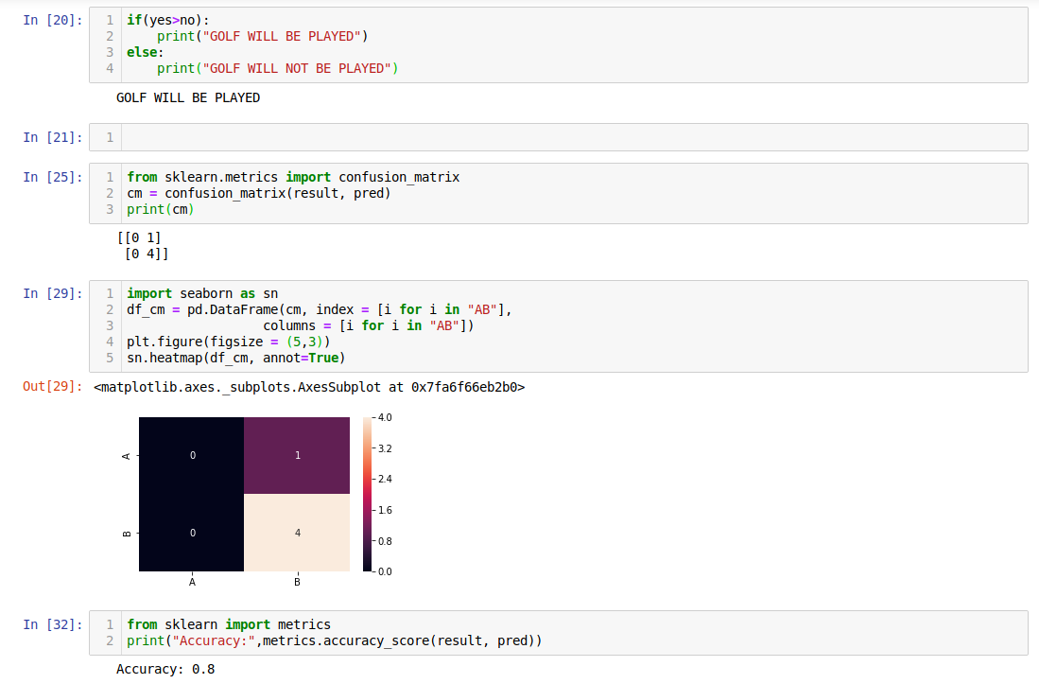

OUTPUT:

LETS PREDICT WHETHER GOLF WILL BE PLAYED OR NOT
Enter weather conditions (fine/rain/cloud): fine
Enter temperature conditions (hot/warm/cold): warm
Enter humidity conditions (high/medium): medium
Enter wind conditions (none/few): none

GOLF WILL BE PLAYED
LETS PREDICT WHETHER GOLF WILL BE PLAYED OR NOT
Enter weather conditions (fine/rain/cloud): rain
Enter temperature conditions (hot/warm/cold): cold
Enter humidity conditions (high/medium): high
Enter wind conditions (none/few): few

GOLF WILL NOT BE PLAYED
LETS PREDICT WHETHER GOLF WILL BE PLAYED OR NOT
Enter weather conditions (fine/rain/cloud): fine
Enter temperature conditions (hot/warm/cold): warm
Enter humidity conditions (high/medium): high
Enter wind conditions (none/few): few

GOLF WILL NOT BE PLAYED

